1. Create a Web form that looks like this sample:  
   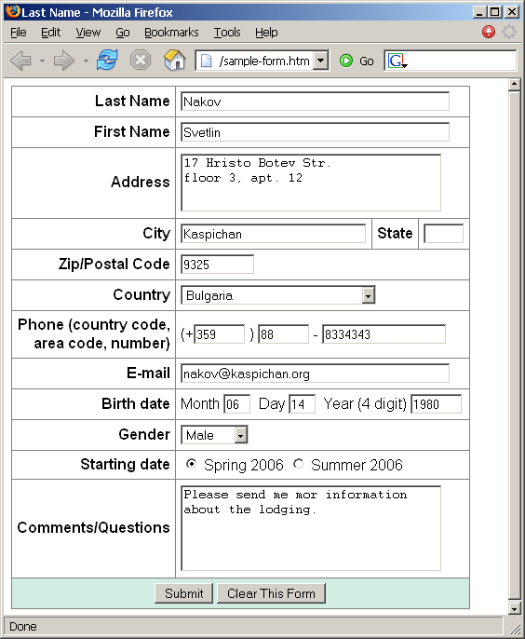
2. Create the following using tables and forms:  
   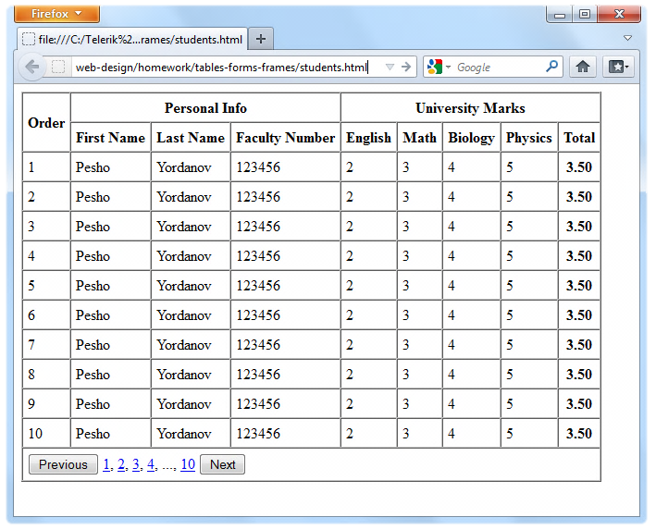
3. Construct the following Grid component:  
   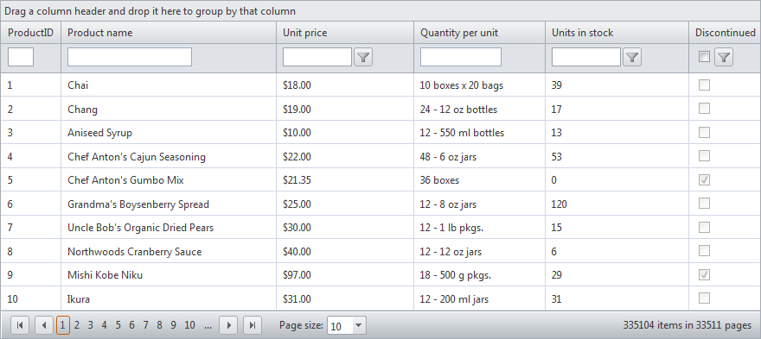  
   Try to make a HTML page, that looks just like the example.Not required to style for the homework
4. \*Create the following HTML Page  
   Hint: Use Fieldsets and Nested tables  
   